CASE STUDY
Major Power Tool Manufacturer and Retailer
Direct Mail / Email / Response & ROI
MID-ATLANTIC REGION • THREE-PHASE CAMPAIGN
CAMPAIGN OVERVIEW

Major Power Tool Manufacturer
A three-phase campaign in the Mid-Atlantic region combining direct mail and email, measured against verified sales matches, revenue and ROI.
Phase 01 / Direct Mail  4-panel self-mailer with tipped-on Sales Agent card in English and Spanish, mailed to 10,791 businesses. |  | Phase 02 / Email  Rich media B2B email blast to 4,545 businesses (3,553 purchased data, 992 client-supplied data).
Phase 03 / Direct Mail  6 x 9 postcard mailed to 10,791 households. |  | Results  456 verified sales matches, a 4.23% response rate, and $163,900.94 net ROI.

PHASE 01 / DIRECT MAIL

4-Panel Self-Mailer
 |  | 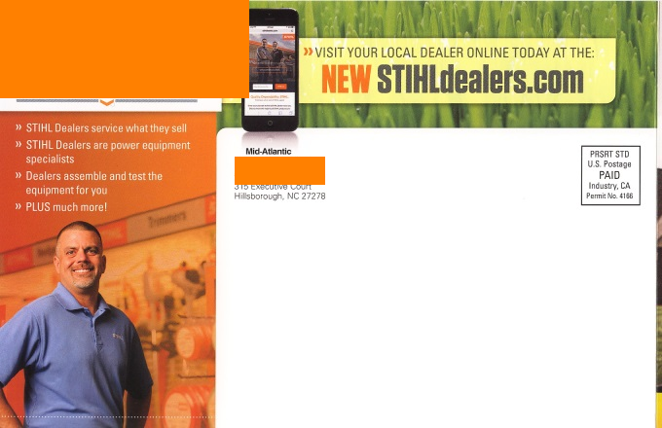
 |  | 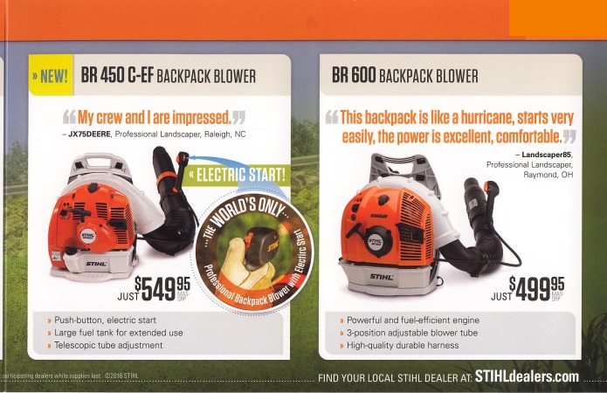
 |  | 
4 Panel Self-Mailer, with tipped on Sales Agent card in English and Spanish
Total Mailing 10,791 Businesses

PHASE 02 / EMAIL

Rich Media Email Blast

Rich Media E-mail Blast, B2B, to 4,545 Businesses
3,553 purchased data, 992 Client-Supplied data
PHASE 03 / DIRECT MAIL

6 x 9 Postcard
 |  | 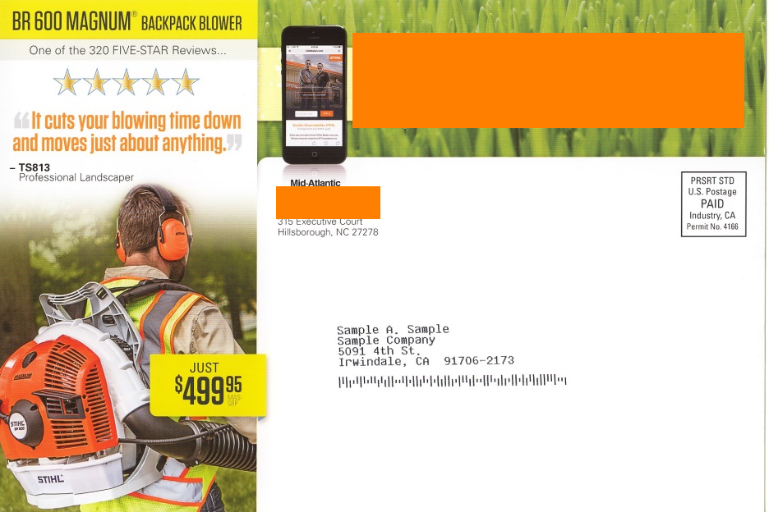
6 x 9 Postcard, Mailed to 10,791 households

RESULTS

Campaign Response

10,791  TOTAL MAILED |  | 456  VERIFIED SALES MATCHES |  | 4.23%  RESPONSE RATE
RESULTS

Revenue vs. Expense

Item | Detail | Amount
Gross Revenue MSRP |  | $180,177.20
Marketing Expenses — Phase #1 | Self-Mailer | $9,630.84
Marketing Expenses — Phase #2 | E-Mail Blast | $1,750.00
Marketing Expenses — Phase #3 | Postcard | $4,895.42
Total Marketing Expenses |  | $16,276.26
Net ROI |  | $163,900.94
RESULTS

Response by Product

Model | Total # Sales | MSRP | % Resp of Total Mailed | % of Total Responders
FS90R | 226 | $299.95 | 2.09% | 49.56%
HS56C | 30 | $399.95 | 0.28% | 6.58%
BR600 | 192 | $499.95 | 1.78% | 42.11%
BR450C | 8 | $549.95 | 0.08% | 1.75%
Total | 456 |  | 4.23% | 100.00%

